103.241.146.51:8080/yogiAccount

User name [b@gmail.com](mailto:b@gmail.com)

Pass b

User name [a@gmail.com](mailto:a@gmail.com)

Pass a

COMPANY YOGI WIRES PVT LTD USER [arun@gmail.com](mailto:arun@gmail.com) passward arun

1. All Ledger opening balance is not updating after creation of ledger

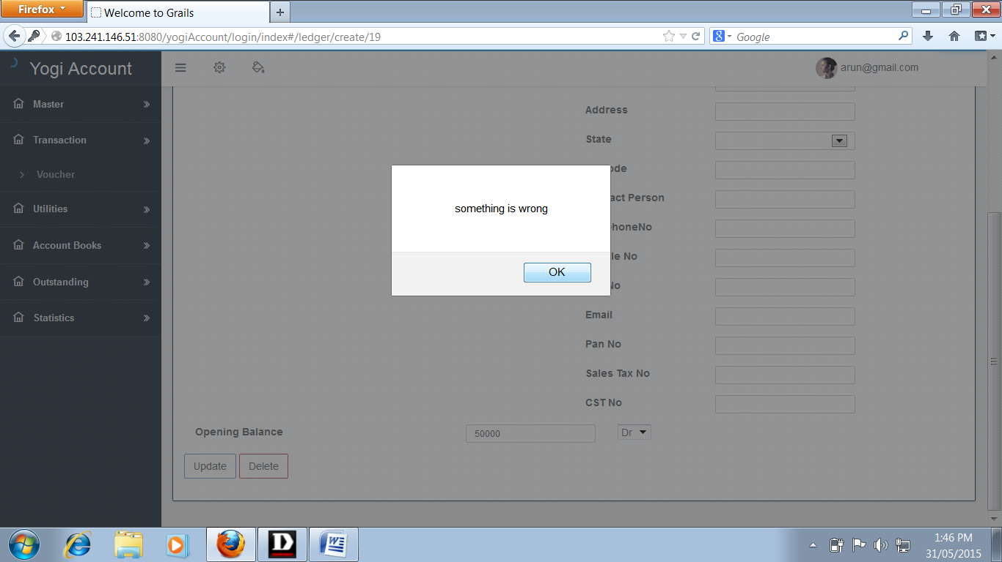

2)bank account is not creating showing error

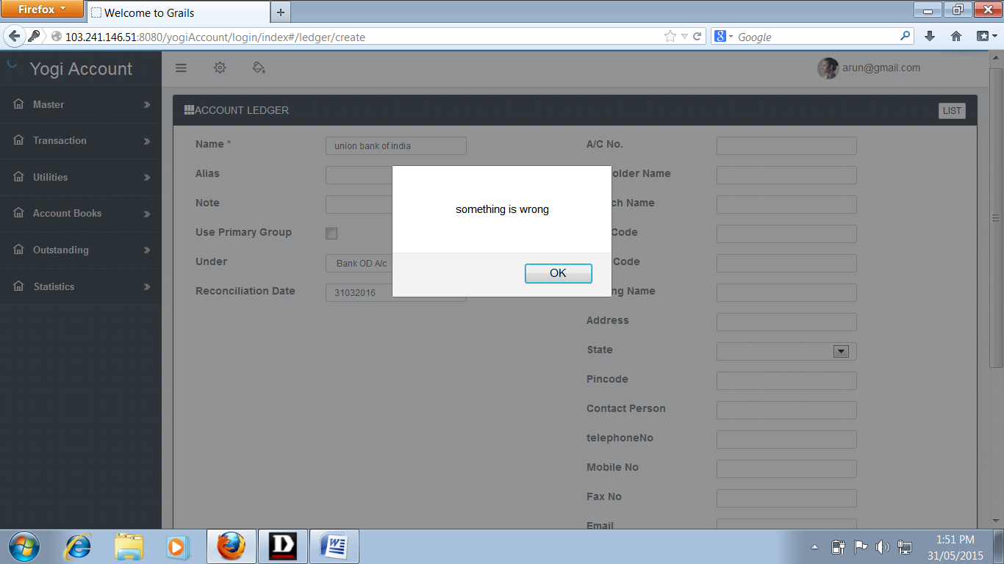

1. Purchase voucher entry showing error

